LAB # 11
Introduction to Test Suite
OBJECTIVE: Grouping the multiple JUnit test cases and constructing a Test Suite program.
Test suite: Test suite is used to bundle a few unit test cases and run them together. In JUnit, both @RunWith and @Suite annotations are used to run the suite tests.
Lab Task:
Make a class having four functions for determining,
- Whether the input integer is odd.
- Whether the input integer is even.
- Whether the input integer is prime.
- For calculating the factorial of that input integer.
Write their test cases and execute them in a single test suite class. Follow all the steps mentioned above in the manual.
CODE:
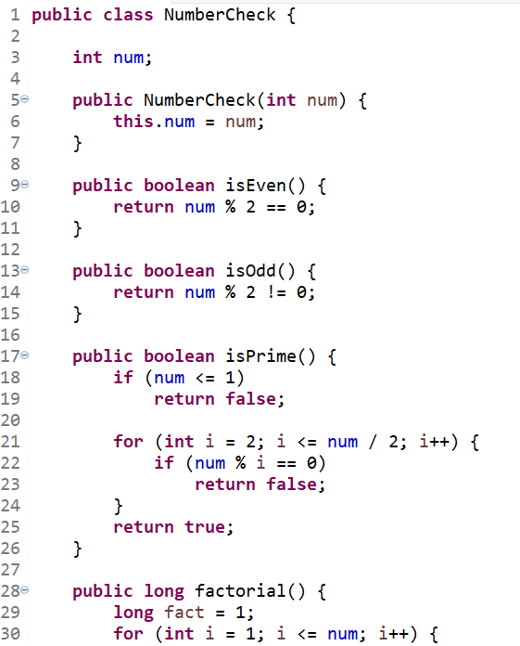
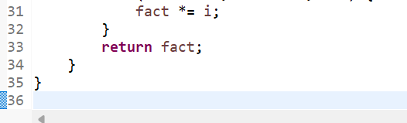

EvenOddTest
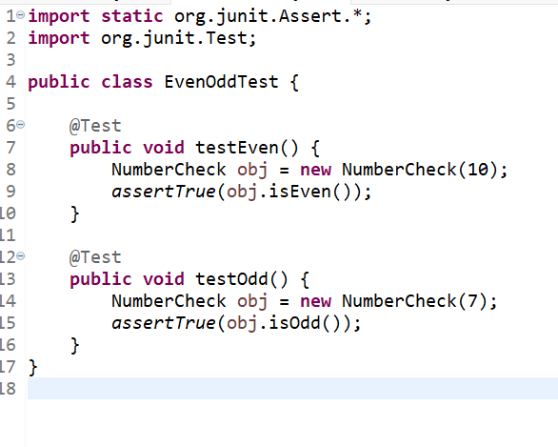

PrimeTest
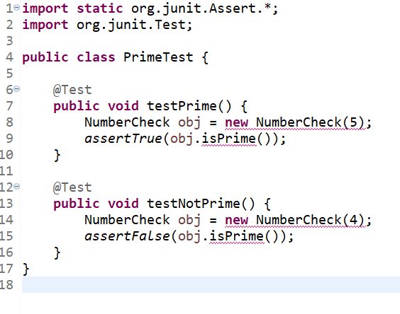

FactorialTest
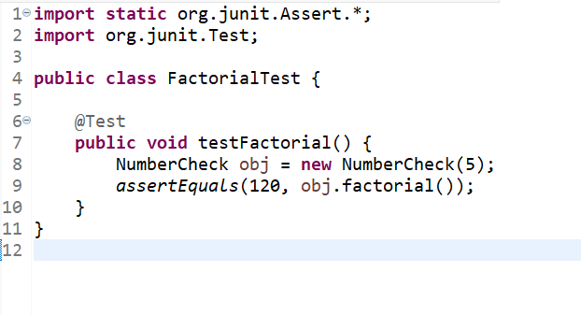

AllTests
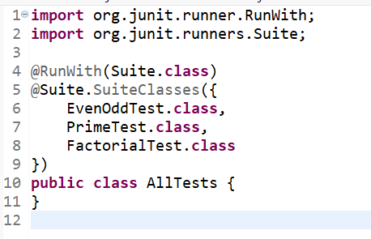

OUTPUT:
